The Office of the Deputy Mayor for Planning and Economic Development

NOTICE OF
funding





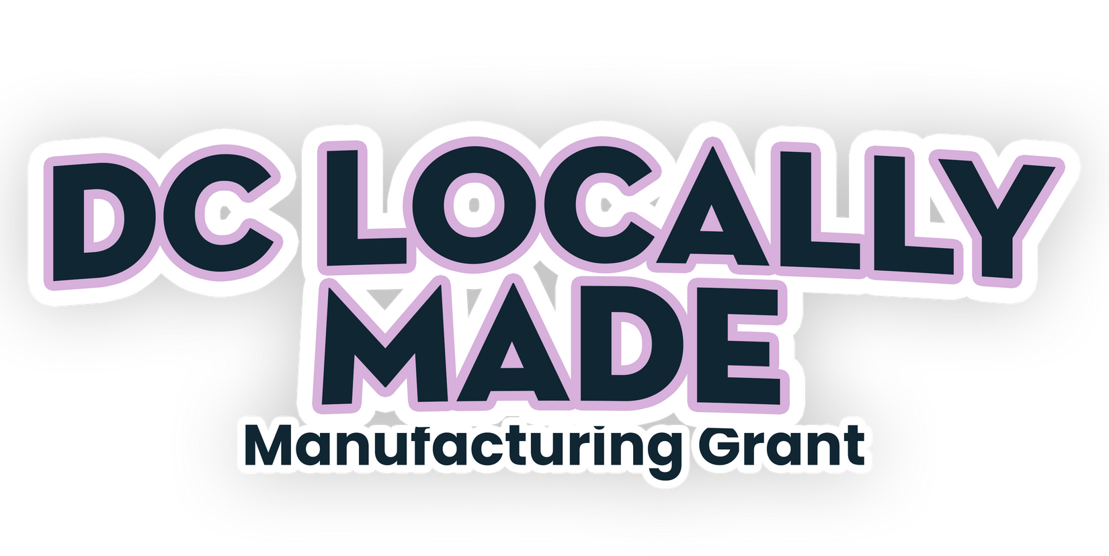
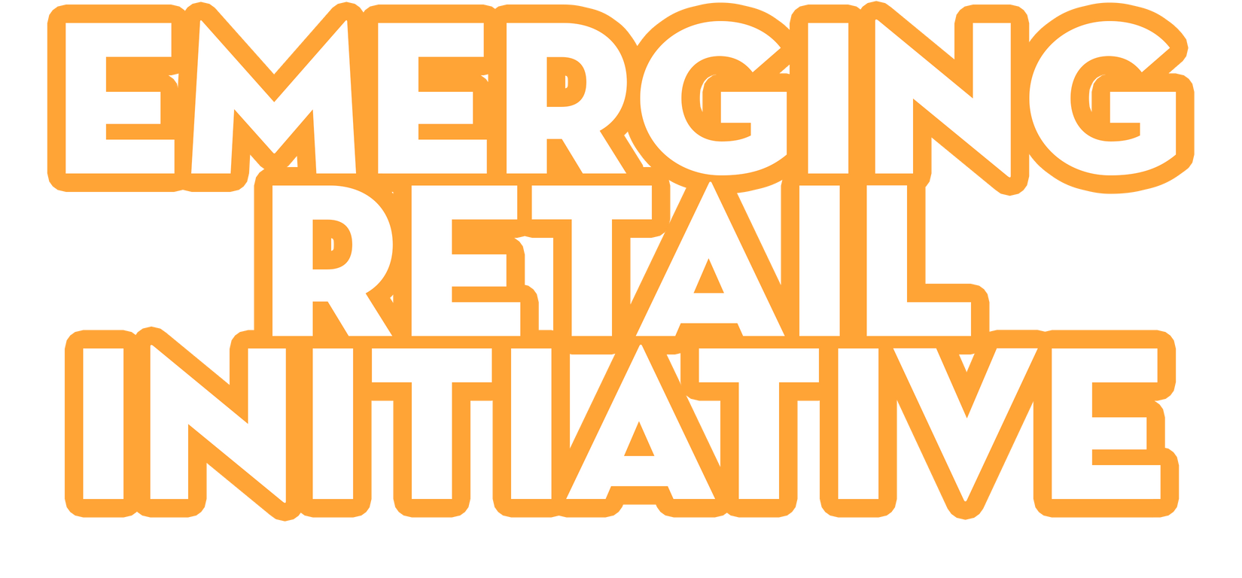
AVAILABILITY

To learn more about upcoming business grant opportunities, visit dmped.dc.gov. Applications open on December 12.



WEEKS TO GO!
4

Is your business located on an eligible corridor?
Scan the QR code to check the map.

Great Streets, Locally Made Manufacturing & Emerging Retail Corridor Map

2025

BUSINESS
grant

CHECKLIST

Business Tax Returns for the past three years
Landlord Affidavit

DC Basic Business License  Insurance Policies Affidavit

DLCP- Certificate of Good Standing Employee Roster and Job Creation
Chart

Evidence of Site Control (Copy of Fully Executed, Unexpired Lease or Deed)
Certificate of Clean Hands (Dated within 90 days prior to application date)

Certificate of Insurance

2025

UPCOMING
ggrraanntt

INFO SESSIONS

WED.

NOV
19
H STREET CORRIDOR

GREAT STREETS & EMERGING RETAIL
Noon—1 p.m. | 1207 H Street NE Register for the upcoming session at https://tinyurl.com/7wbc8txm.

THURS.

NOV
20
MT. VERNON TRIANGLE

GREAT STREETS & EMERGING RETAIL
10—11 a.m. | Bar Chinois, 455 Eye St NW Register for the upcoming session at https://tinyurl.com/7wbc8txm.

